**2013**

**SUSMITA PODDER**

**1/19/2013**



SCHOOL MANAGEMENT SYSTEM

Table of Contents

[INTRODUCTION AND OBJECTIVE 4](#_Toc346626317)

[INTRODUCTION 4](#_Toc346626318)

[OBJECTIVE 4](#_Toc346626319)

[SYSTEM ANALYSIS 4](#_Toc346626320)

[IDENTIFICATION OF NEED 5](#_Toc346626321)

[PRELIMINARY INVESTIGATION 5](#_Toc346626322)

[FEASIBILITY STUDY 5](#_Toc346626323)

[PROJECT PLANNING 5](#_Toc346626324)

[TRACKING GANTT 5](#_Toc346626325)

[PROJECT SCHEDULING 5](#_Toc346626326)

[PERT CHART (NETWORK DIAGRAM) 5](#_Toc346626327)

[GANTT CHART 6](#_Toc346626328)

[SOFTWARE REQUIREMENT AND SPECIFICATION 7](#_Toc346626329)

[FUNCTIONAL REQUIREMENTS 7](#_Toc346626330)

[TECHNICAL SPECIFICATION 10](#_Toc346626331)

[SOFTWARE ENGINEERING PARADIGM APPLIED 10](#_Toc346626332)

[DATA MODELS 10](#_Toc346626333)

[CONTEXT DIAGRAM 10](#_Toc346626334)

[DATA FLOW DIAGRAM (DFD) 11](#_Toc346626335)

[CONTROL FLOW DIAGRAM 15](#_Toc346626336)

[STATE DIAGRAM / SEQUENCE DIAGRAM 15](#_Toc346626337)

[ENTITY RELATIONSHIP MODEL 15](#_Toc346626338)

[CLASS DIAGRAM / CRC MODEL /COLLABORATION DIAGRAM / USE-CASE DIAGRAM / ACTIVITY DIAGRAM 17](#_Toc346626339)

[SYSTEM DESIGN 18](#_Toc346626340)

[MODULARISATION DETAILS 18](#_Toc346626341)

[SCHOOL MANAGEMENT SERVER 19](#_Toc346626342)

[SCHOOL MANAGEMENT CLIENT 19](#_Toc346626343)

[SCHOOL MANAGEMENT DATABASE 20](#_Toc346626344)

[DATA INTEGRITY AND CONSTRAINTS 20](#_Toc346626345)

[DATABASE AND TABLE DESIGN 20](#_Toc346626346)

[PROCEDURAL DESIGN / OBJECT ORIENTED DESIGN 21](#_Toc346626347)

[USER INTERFACE DESIGN 22](#_Toc346626348)

[TEST CASES 22](#_Toc346626349)

[UNIT TEST CASES 22](#_Toc346626350)

[SYSTEM TEST CASES 22](#_Toc346626351)

[CODING 23](#_Toc346626352)

[COMPLETE PROJECT CODING 23](#_Toc346626353)

[COMMENTS AND DESCRIPTION OF CODING SEGMENTS 23](#_Toc346626354)

[STANDARDIZATION OF THE CODING 23](#_Toc346626355)

[CODE EFFICIENCY 23](#_Toc346626356)

[ERROR HANDLING 23](#_Toc346626357)

[PARAMETERS CALLING / PASSING 23](#_Toc346626358)

[VALIDATION CHECKS 23](#_Toc346626359)

[TESTING 23](#_Toc346626360)

[TESTING TECHNIQUES AND TESTING STRATEGIES USED 23](#_Toc346626361)

[TESTING PLAN USED 23](#_Toc346626362)

[TESTING REPORTS 23](#_Toc346626363)

[UNIT TEST CASES 23](#_Toc346626364)

[SYSTEM TEST CASES 24](#_Toc346626365)

[DEBUGGING AND CODE IMPROVEMENT 24](#_Toc346626366)

[SYSTEM SECURITY MEASURES 24](#_Toc346626367)

[DATABASE / DATA SECURITY 24](#_Toc346626368)

[CREATION OF USER PROFILES AND ACCESS RIGHTS 24](#_Toc346626369)

[COST ESTIMATION 24](#_Toc346626370)

[COST ESTIMATION MODEL 24](#_Toc346626371)

[REPORTS 24](#_Toc346626372)

[FUTURE SCOPE AND FURTHER ENHANCEMENT 25](#_Toc346626373)

[BIBLIOGRAPHY 25](#_Toc346626374)

[APPENDICES 25](#_Toc346626375)

[GLOSSARY 25](#_Toc346626376)

# INTRODUCTION AND OBJECTIVE

## INTRODUCTION

The population of our country is increasing rapidly, but the resources for providing proper education to the children are limited. So we need to utilize our existing school management processes properly with the help of digital technologies.

Most of the schools are managed by a single authority like head master or a group of people like governing body. But in this fast paced world people tend to switch jobs. If the key people leave the school then the quality of education and school management deteriorates. There are so many dependencies on the school management personnel. We can eradicate this dependency by deploying a computerized solution for managing school.

Nowadays both of the parents are employed for most kids and they don’t have enough time to interact with teachers frequently. We need a computerized system to manage interaction between parents and teachers.

We will implement a school management system to address these issues and bring up an efficient system to manage activities of a school using single software.

## OBJECTIVE

School Management System is versatile and complete end-to-end school management software .School Management System is used to enhance the administrative efficiency of educational institutions. It is an interactive platform for all entities viz. Students, Teachers, Management, Parents. It is a simple yet powerful one point integrated platform that connects all the departments of an institution namely office, fee counter, library, hostel, stores, academics, activity center and so on.

# SYSTEM ANALYSIS

## IDENTIFICATION OF NEED

When I was a kid I saw my parents coming to the school for submitting the remuneration and other reasons. The entire data was written using pen and papers so undoubtedly it took lots of time completing even minor queries. Nowadays I see my relatives going to the school to admit their kids and they face huge problems as no proper procedure is followed even by larger and more reputed institutes. I have always felt that there is a need of a proper procedure which could not only save lots of time of both the school authority and the guardians, also easy to maintain the entire process. So I really feel that the modernization of technology could be used to minimize these problems. That is why a proper application or software is required to ease the task of the school administration and save the time of the parents as well.

## PRELIMINARY INVESTIGATION

I started talking to my relatives and neighbors who have recently admitted their child to the schools or they are in the process of admitting them. Naturally, they are the ones who know the problems very well. I also spoke with some of school administrations in my locality about the problems they faced and what exactly would they want if they are given software like School Management System just to get an idea on what could the points be if we want to develop a new application to minimize school management related problems and difficulties. I obviously then consulted with some IT professionals and software engineers and expressed my view to them. I was really amazed to see their positive response on this matter and I got helps in many ways from them. After completing all this process I decided to develop this application for sure.

## FEASIBILITY STUDY

We all know that the numbers of school is growing as fast as Information Technology. Developing an application is very easy these days so people would love to use technology ease their tasks. There is need and there is solution so undoubtedly this software is going to be appreciated by the market.

## PROJECT PLANNING

### TRACKING GANTT

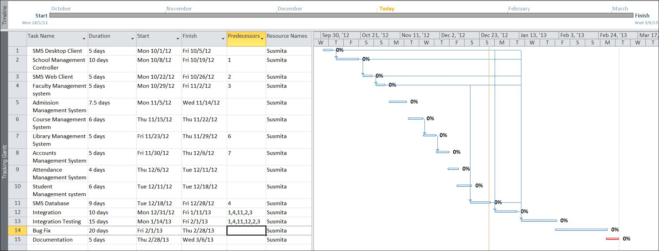

## PROJECT SCHEDULING

### PERT CHART (NETWORK DIAGRAM)

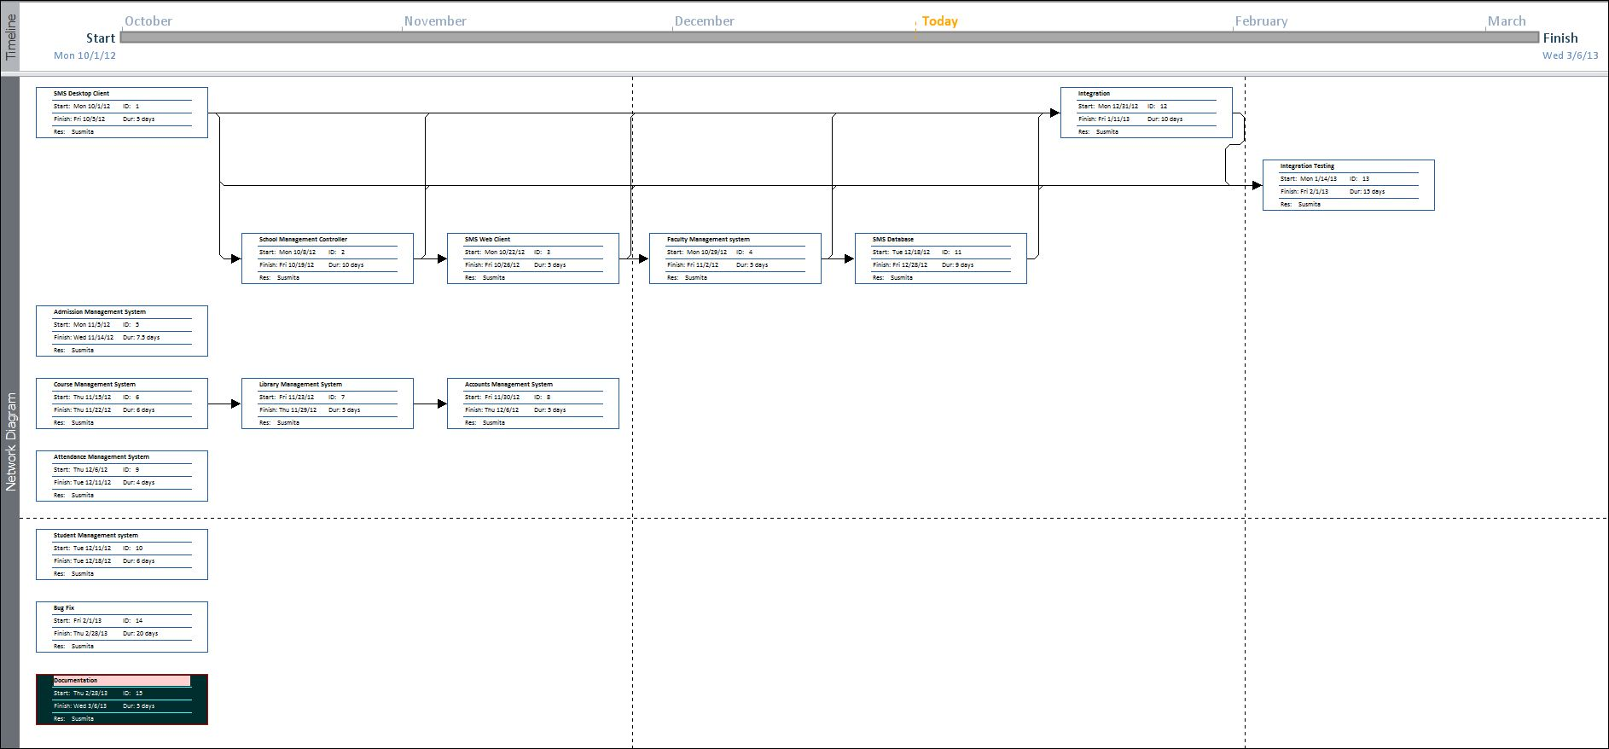

### GANTT CHART

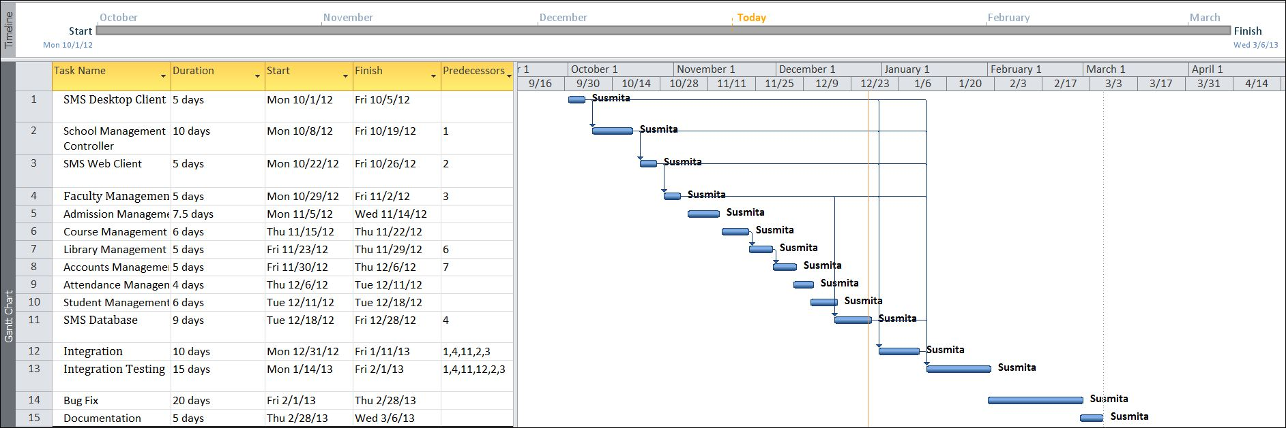

## SOFTWARE REQUIREMENT AND SPECIFICATION

### FUNCTIONAL REQUIREMENTS

#### View and Enter new Student and Employee information

**Introduction**

The details of a new student are stored into a student profile. Only School administration department can enter that details of new student but and teachers can only updated the existing student status. Details of employee are also kept into individual employee profile and it will also be updated by School Administration System.

**Input**

Relevant student and employee data like name, address, contact no., applying for which class.

**Processing**

Employee will enter data in SMS and create a new Student enrolment no, as well as a new code number for Employee.

**Output**

SMS will generate Enrolment no. for Student and Code no. for Employee .Details can be viewed later on whenever required.

#### View and Enter new timetable information

**Introduction**

Employee can view the time table and can also update the timetable information.

**Input**

Employee number, department number and Week range

**Processing**

Employee number and department number must be unique, and when entering timetable of any employee or teacher both values must be valid references. Week range must be between 1to 52.

**Output**

Teacher and Student both can see the time table.

#### Security

**Introduction**

Only the high level members of the School and Network manager will have access to the system for securing their important data from others.

**Input**

System username and password

**Processing**

The network operating system in the department will be used to enforce security. Another security level should also be incorporated to make the system more secure.

**Output**

All data are secured and that can be used in future.

#### Changing Password and Username

**Introduction**

Change existing username and password

**Input**

New username and password

**Processing**

Old username and password will be replaced by user provided new username and password after authenticating.

**Output**

Password and Username can be changed according to the Employee requirement whenever they want to change for better security of the System.

#### Mail Notification

**Introduction**

If holiday is declared suddenly, all students, teachers and employees are informed by sending them a mail.

**Input**

Student and Teacher’s name and email id.

**Processing**

Employee will enter the name, email id and reason of holidays in the SMS and it will generate a message.

**Output**

Employee and Students get a message from SMS.

#### Exam Grade Details

**Introduction**

Data sheets are prepared for individual class. And each datasheet is given via email to the student of the corresponding class.

**Input**

Student name, marks in individual subject, attendance, class performance**.**

**Processing**

Grade card can be generated for individual students. Exam administrators would need to be able to view, update, delete, print and add grade details.

**Output**

A printed Grade card can be given to the student as well as an email can be received by the student with Grade card.

#### Fees Details

**Introduction**

Fees details of all Students are kept and they are reminded after every 4 days after last date. Late Fee is also charged after last date.

**Input**

Student name, enrolment no, remaining fees, last date of deposit amount.

**Processing**

SMS automatically generates a message and send it to the student email id.

**Output**

Students are reminded after every 4 days after last date.

### non FUNCTIONAL REQUIREMENTS

* The software must have a easy to use graphic user interface as it is going to be used by all types of users, like professors and clerks.
* The software should be password protected to secure confidential data.
* The database must be encrypted so that no one could see the accounts information of the organization even if the database is somehow hacked.
* The application must be fast and flexible so that waiting time gets reduced.
* There must be a backup and restore feature so that the valuable data stays secure forever.

## SOFTWARE ENGINEERING PARADIGM APPLIED

Project Category

## DATA MODELS

### CONTEXT DIAGRAM

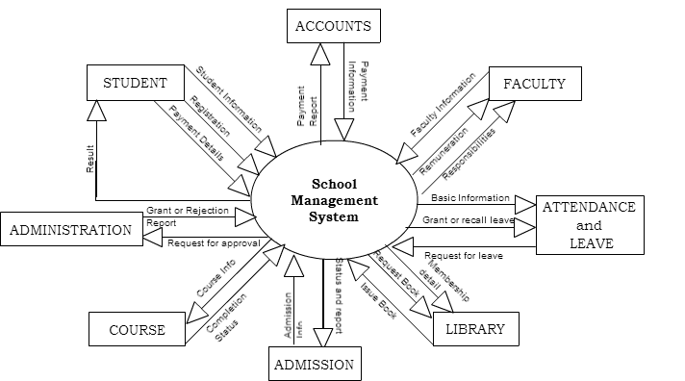

### DATA FLOW DIAGRAM (DFD)

#### LEVEL 0 DFD

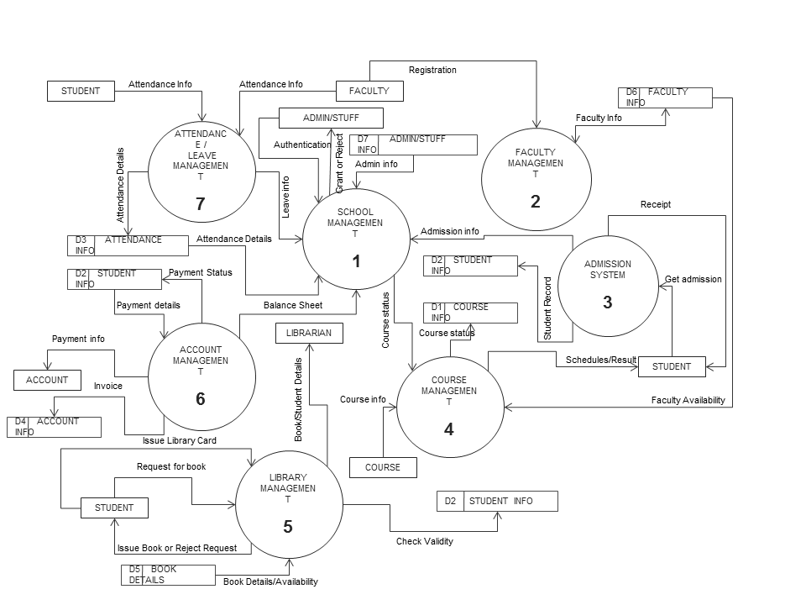

#### LEVEL 1 DFD

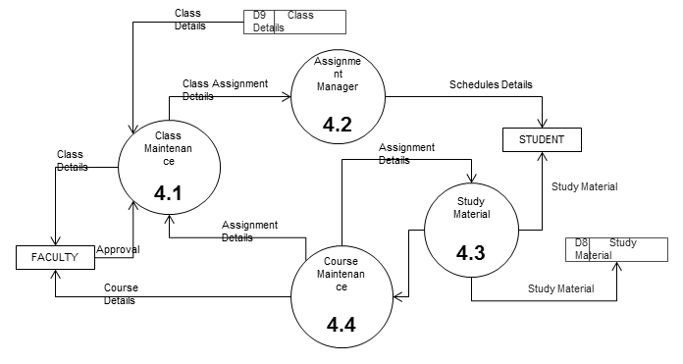

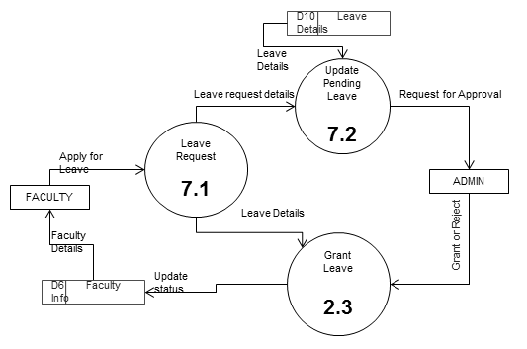

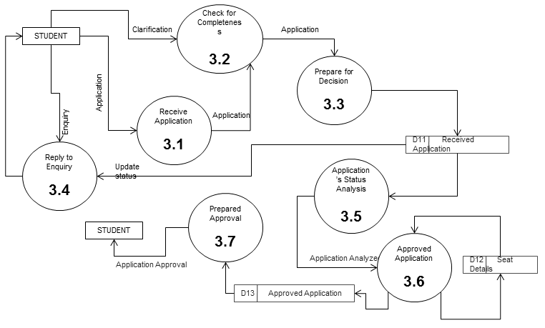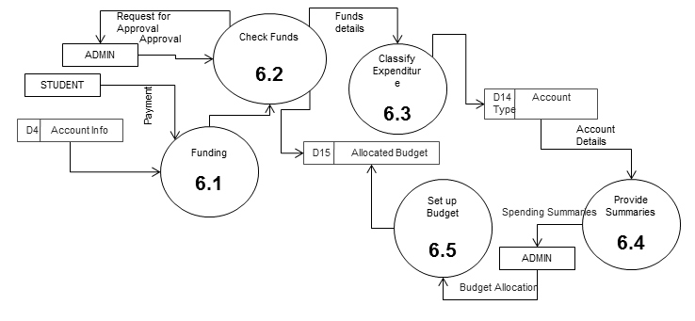

#### LEVEL 2 DFD

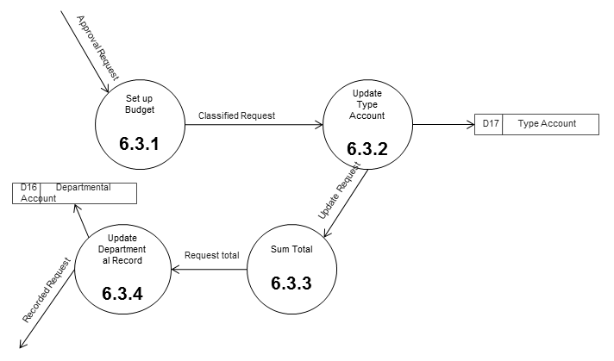

### CONTROL FLOW DIAGRAM

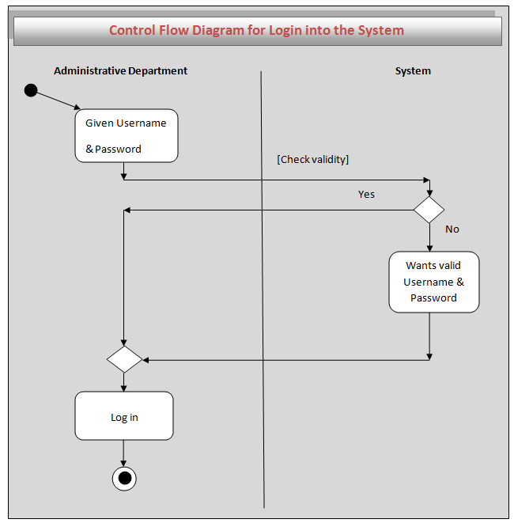

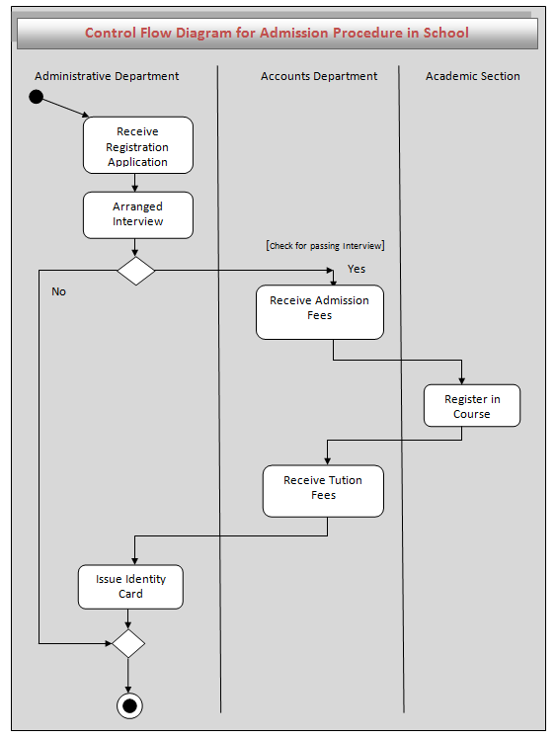

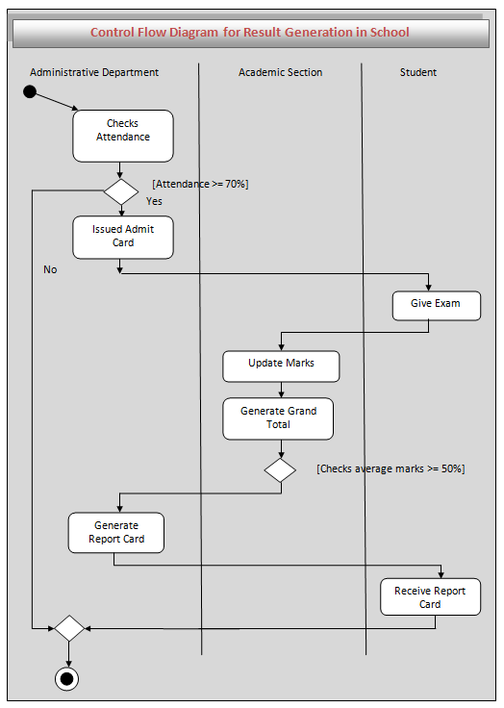

### SEQUENCE DIAGRAM

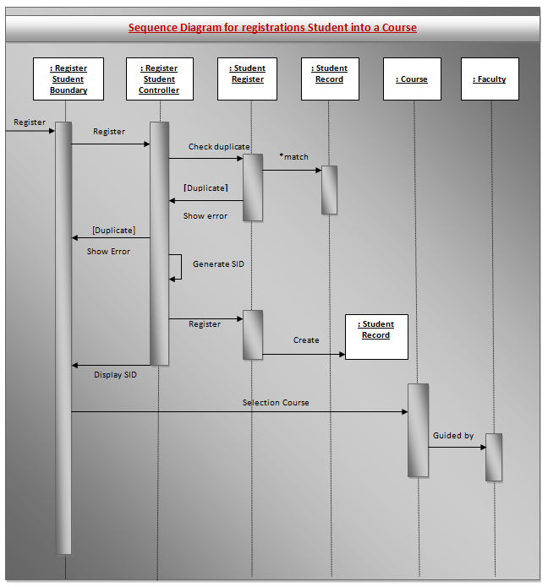

### ENTITY RELATIONSHIP MODEL

We will design a RDBMS for School Management System. The entities and their attributes are listed below. Attributes in Bold letter is the unique key.

|  |  |
| --- | --- |
| **Entities** | **Attributes** |
| Student | **Student\_ID**, Student\_DOB, Student\_Name, Student\_Parent\_Name, Student\_Address, Student\_Admission\_Date, Student\_Course\_Name, Student\_Contact |
| Account | **Transaction\_ID**, Transaction\_Amount, Transaction\_Type, Transaction\_Reason,Account\_Balance |
| Admin | **Staff\_ID**, Staff\_Name, Staff\_Permission\_Level, Staff\_Address, Staff\_Admission\_Date, Staff\_Course\_Name, Staff\_Contract\_details, Staff\_Join\_Date, Staff\_Email, Staff\_Role |
| Books | **Book\_ID**, Book\_Name, Book\_Author, Purchase\_Date, Book\_Status, Book\_Description,Purchase\_Amount |
| Faculty | **Faculty\_ID**, Faculty\_Name, Faculty\_Address, Faculty\_Join\_Date, Faculty\_Course\_Under, Faculty\_Contact\_Details, Faculty\_Salary\_Details |
| Course | **Course\_ID**, Course\_Faculty, Course\_Name, Required\_Qualification, Course\_Fees, Course\_Admission\_Date, Students\_Under, Course\_Description |

**Relationship between Entities:**

School Management System has Courses 1 : N

School Management SystemhasStudents 1 : N

School Management System has Faculties1 : N

School Management System has Admin 1 : 1

Studenthas Attendance1 :1

AdminChecksAttendance1 : 1

StudentsreadsBooksM : N

StudentspaysAccount1 : 1

AdminControlsAccount1 : 1

Students Studies in Course N:1

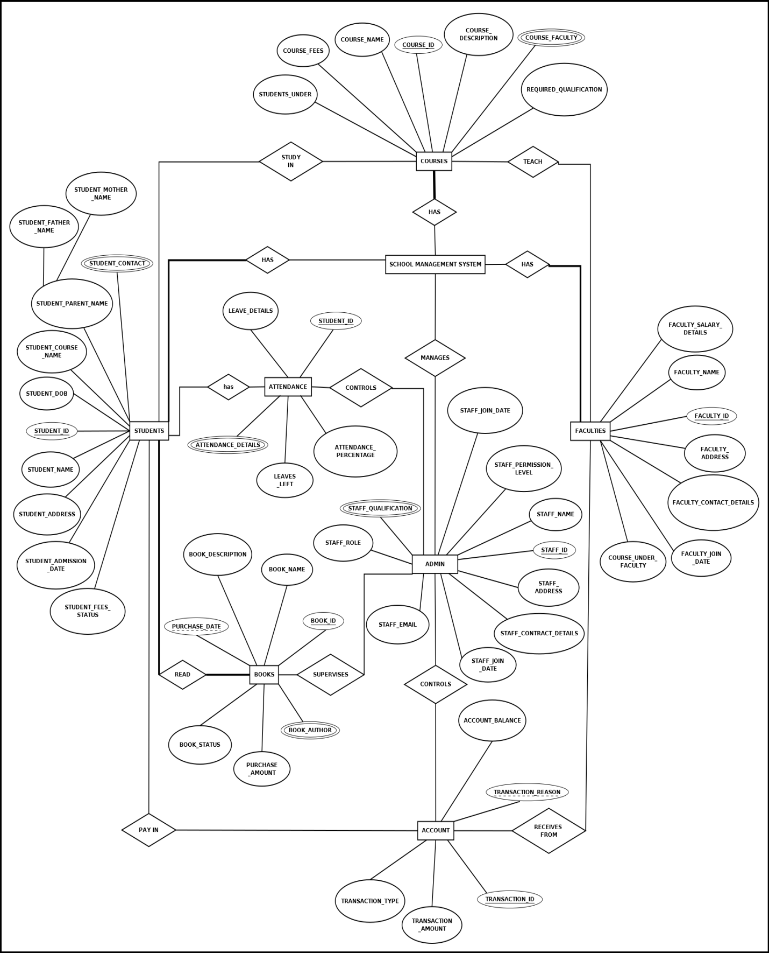

### CLASS DIAGRAM / CRC MODEL /COLLABORATION DIAGRAM / USE-CASE DIAGRAM / ACTIVITY DIAGRAM

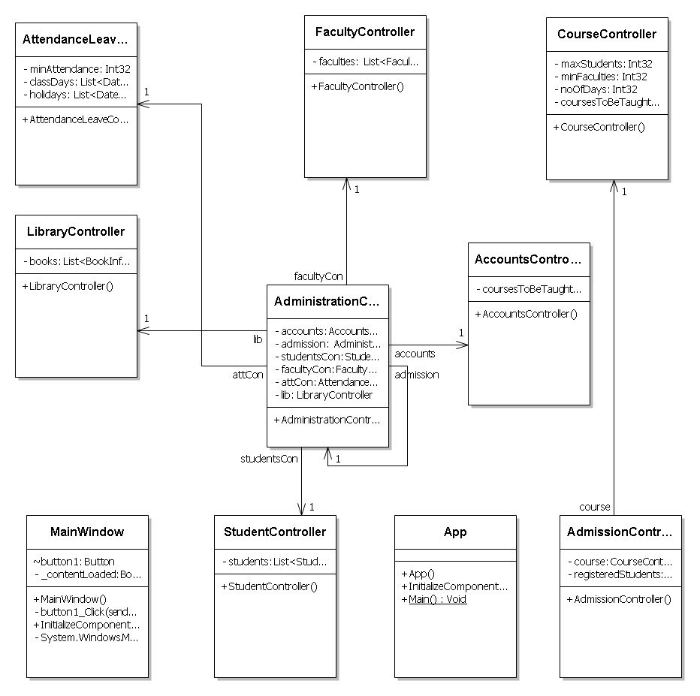

# SYSTEM DESIGN

## MODULARISATION DETAILS

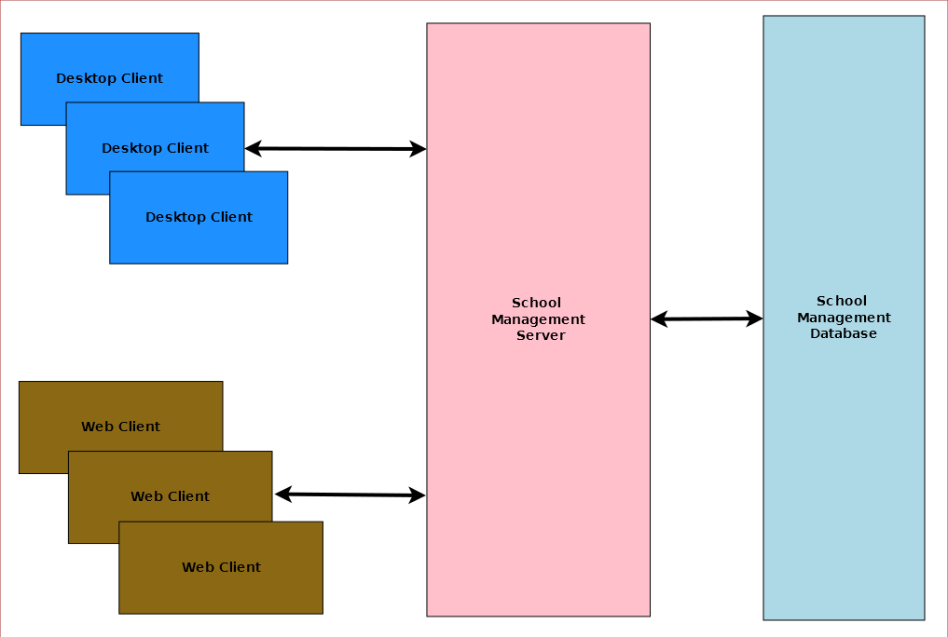

School Management System is divided three main modules such as:

1. School Management Server
2. School Management Client
3. School Management Database

### SCHOOL MANAGEMENT SERVER

School Management server is a singleton server designed provide services for school management system. It controls various activities required for the school management system. To manage these activities it has several sub modules such as:

1. Admission Management
2. Student Management
3. Faculty Management
4. Course Management
5. Attendance & Leave Management
6. Library Management
7. Accounts Management
8. Administration Management

### SCHOOL MANAGEMENT CLIENT

School Management System will provide two different clients for the convenience of the user. Desktop client is for doing bulk activities and faster tasks. Web client will allow instant access from anywhere and anytime.

### SCHOOL MANAGEMENT DATABASE

School Management System will have a unified database for storing all the information. It can be a networked database or a database situated in the server machine.

## DATA INTEGRITY AND CONSTRAINTS

?????????? database related issues and limitations

## DATABASE AND TABLE DESIGN

The database used for this software is called **smsdb**. A screenshot from the MySQl workbench is given below. It shows the tables and its columns. The first row is the primary key.

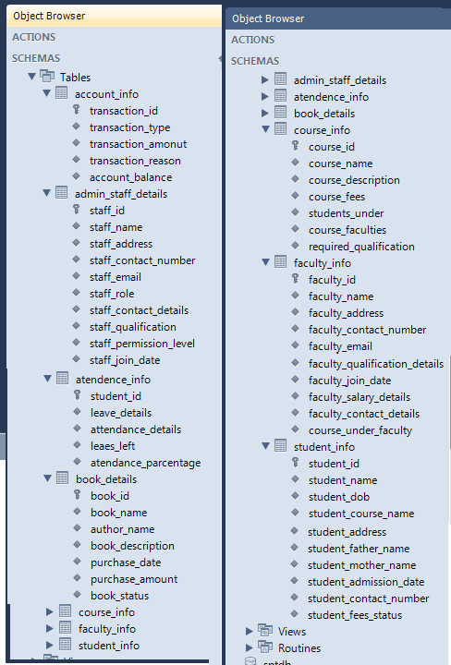

## PROCEDURAL DESIGN / OBJECT ORIENTED DESIGN

## USER INTERFACE DESIGN

## TEST CASES

### UNIT TEST CASES

|  |  |  |  |  |
| --- | --- | --- | --- | --- |
| **TEST CASE ID** | **ITEM** | **DESCRIPTION** | **ACTUAL RESULT** | **TESTED BY** |
| SMS – 001 | Login | Enter User ID and Password for Login. | Successfully Logged in. | Susmita |
| SMS – 002 | Cancel | Select Cancel to close Login window. | Successfully Canceled. | Susmita |

### SYSTEM TEST CASES

|  |  |  |  |  |
| --- | --- | --- | --- | --- |
| **TEST CASE ID** | **ITEM** | **DESCRIPTION** | **ACTUAL RESULT** | **TESTED BY** |
| SMS – 001 | Login | Enter User ID and Password for Login. | Successfully Logged in. | Susmita |
| SMS – 002 | Cancel | Select Cancel to close Login window. | Successfully Canceled. | Susmita |
| SMS – 003 | Admission | To add a new student enter the Student\_ID, Student\_DOB, Student\_Name, Student\_Parent \_Name, Student\_Address, Student\_Admission\_ Date,Student\_course \_Name, Student\_Contact | New Student is added to the School Management System. | Susmita |
| SMS – 004 | ViewStudentStatus | Enter Student\_ID, Student\_Name, Student\_Course\_Name of the Student. | Show the Student Details. | Susmita |
| SMS – 005 | EditStudentStatus | Select the Student and Click the Edit option. Now edit the Student Details and submit the Details. | Student Details successfully updated. | Susmita |
| SMS - 006 | Faculty | To add new faculty enter Faculty ID, Name, Address, Contact No. etc details of the Faculty. | New Faculty is added to the School Management System. | Susmita |
| SMS – 007 | Submit | Select Submit to add the details of the Faculty. | Successfully added the details of the Faculty into School Management System. | Susmita |
| SMS – 008 | Cancel | Select Cancel to close the Faculty window. | Successfully cancelled. | Susmita |
| SMS – 009 | Course | Click Course to open Course window. | Successfully opened. | Susmita |
| SMS – 010 | Submit | Select Submit to add the details of the Course. | Successfully added the details of the Course into School Management System. | Susmita |
| SMS – 011 | Cancel | Select Cannel to close the Course window. | Successfully cancelled. | Susmita |
| SMS - 012 | Student | Enter the user id and password of the student. | Successfully login the Student into School Management System. | Susmita |
| SMS - 013 | Enter | Select Enter to show the details of the Student from Mobile. | Successfully shows the details. | Susmita |
| SMS – 014 | Result | Select Result for showing the marks of the student. | Successfully shown. | Susmita |

# CODING

## COMPLETE PROJECT CODING

## COMMENTS AND DESCRIPTION OF CODING SEGMENTS

## STANDARDIZATION OF THE CODING

## CODE EFFICIENCY

## ERROR HANDLING

## PARAMETERS CALLING / PASSING

## VALIDATION CHECKS

# TESTING

## TESTING TECHNIQUES AND TESTING STRATEGIES USED

We have vigorously tested the application to make it error free and smooth. To achieve our goal we tested the modules differently inside the codes and then tested the entire application as a whole to mark its drawbacks.

## TESTING PLAN USED

## TESTING REPORTS

### UNIT TEST CASES

|  |  |  |
| --- | --- | --- |
| Test Case Id | Comments | Status |
| SMS – 001  SMS – 002 | NA  NA | PASS  PASS |

### SYSTEM TEST CASES

|  |  |  |
| --- | --- | --- |
| Test Case Id | Comments | Status |
| SMS – 001 | NA | PASS |
| SMS – 002  SMS – 003  SMS – 004  SMS – 005  SMS – 006  SMS – 007  SMS – 008  SMS – 009  SMS – 010  SMS – 011  SMS – 012  SMS – 013  SMS – 014  SMS – 015  SMS – 016  SMS – 017  SMS – 018  SMS – 019  SMS – 020  SMS – 021  SMS – 022  SMS – 023  SMS – 024  SMS – 025  SMS – 026  SMS – 027  SMS – 028  SMS – 029  SMS – 030 | NA  NA  NA  NA  NA  NA  NA  NA  NA  NA  NA  NA  NA  NA  NA  NA  NA  NA  NA  NA  NA  NA  NA  NA  NA  NA  NA  NA  NA | PASS  PASS  PASS  PASS  PASS  PASS  PASS  PASS  PASS  PASS  PASS  PASS  PASS  PASS  PASS  PASS  PASS  PASS  PASS  PASS  PASS  PASS  PASS  PASS  PASS  PASS  PASS  PASS  PASS |

## DEBUGGING AND CODE IMPROVEMENT

# SYSTEM SECURITY MEASURES

* School Management System is password protected software. It will be developed such a way that the admin will have complete control on the school’s data.
* Admin can create account with various permission levels, like clerk, librarian, teacher, admin etc. so that the users can see relevant data only.

## DATABASE / DATA SECURITY

* The data of the school will be stored in the database with an encrypted format so even if someone hacks the database somehow still he can make no real harm.
* The software will provide a backup and restore feature in case of loss of data.

## CREATION OF USER PROFILES AND ACCESS RIGHTS

* The software asks for a predefined user-type, username and password to use its feature.
* All the data are not available for all types of user, for example, only an admin can use all the fields of the application. On the other hand, a clerk can only enter data and see data from some selected fields. A librarian can use library related data only.

# COST ESTIMATION

## COST ESTIMATION MODEL

??????????????????????????

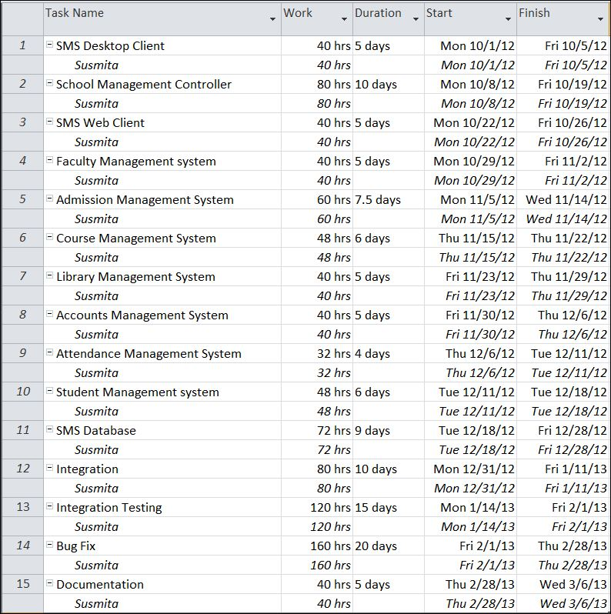

# REPORTS

List of reports that are likely to be generated in this software are given below:

* Results & Grade report can be generated
* Class toppers will be given a certificate as a token of appreciation
* List of students can be generated
* List of teachers can be generated
* List of courses can be generated
* Course details can be generated
* Fund details can be generated
* Yearly donation report can be generated
* Salary slips can be created

# FUTURE SCOPE AND FURTHER ENHANCEMENT

* Mobile application could be developed for students’ guardians for querying about various details.
* Support for Linux operating system could be added.
* Online result checking and fees payment feature could be added.

# BIBLIOGRAPHY

## Websites

* <http://en.wikipedia.org>
* http://en.wikipedia.org/wiki/Windows\_Presentation\_Foundation
* <http://msdn.microsoft.com/en-us/>
* http://www.c-sharpcorner.com/beginners/
* <http://www.microsoft.com/en-us/default.aspx>
* <http://www.codeplex.com/>
* http://searchitchannel.techtarget.com/
* <http://stackoverflow.com/>
* <http://www.codeguru.com/>
* http://www.csharpcourse.com/
* <http://www.w3schools.com>
* <http://blogs.technicise.com/>
* http://connect.technicise.com/
* <http://www.mysql.com/>
* http://www.mysql.com/support/
* <http://dev.mysql.com/>
* http://dev.mysql.com/support/
* <http://www.homeandlearn.co.uk/csharp/csharp.html>
* <http://www.wpftutorial.net/Home.html>
* *http://netbeans.org/*
* https://www.facebook.com/
* <https://developers.facebook.com/>
* <https://developers.facebook.com/apps>
* <https://www.facebook.com/creatormyapp>
* https://www.facebook.com/help/
* https://twitter.com/#
* <https://dev.twitter.com/>
* <https://dev.twitter.com/discussions/3477>
* https://support.twitter.com/
* <https://developers.google.com/>
* <https://maps.google.co.in/>
* http://support.google.com/maps/?hl=en&rd=1
* <http://www.youtube.com/?gl=IN>
* <http://blendinsider.com/>
* https://github.com/
* <https://github.com/anirban-nandy>
* [https://github.com/anirban-nandy/DailyNoteBook](https://github.com/%20anirban-nandy%20/DailyNoteBook)
* <http://learn.github.com/p/intro.html>
* <http://www.vogella.com/articles/Git/article.html>
* <http://try.github.com/levels/1/challenges/1>
* <https://enterprise.github.com/support>
* <https://support.enterprise.github.com/home>

## Books

* **Programming Java** - E. R. Balaguruswamy.
* Fundamentals of software engineering by Rajib Mall.
* Pro C# 2010 and the .NET 4.0 Platform by Andrew Troselen.
* C# Programming by Rob Miles.

# APPENDICES

## IDE:

### Visual Studio 2010

visual_studio_logo

Microsoft Visual Studio is a powerful IDE that ensures quality code throughout the entire application lifecycle, from design to deployment. Whether we are developing applications for SharePoint, the web, Windows, Windows Phone, and beyond, Visual Studio is the ultimate all-in-one solution. Visual Studio includes a [code editor](http://en.wikipedia.org/wiki/Code_editor) supporting [IntelliSense](http://en.wikipedia.org/wiki/IntelliSense) as well as [code refactoring](http://en.wikipedia.org/wiki/Code_refactoring). The integrated [debugger](http://en.wikipedia.org/wiki/Microsoft_Visual_Studio_Debugger) works both as a source-level debugger and a machine-level debugger. Other built-in tools include a forms designer for building [GUI](http://en.wikipedia.org/wiki/GUI) applications, web designer, [class](http://en.wikipedia.org/wiki/Class_(computing)) designer, and [database schema](http://en.wikipedia.org/wiki/Database_schema) designer. It accepts plug-ins that enhance the functionality at almost every level—including adding support for [source-control](http://en.wikipedia.org/wiki/Source_control) systems (like [Subversion](http://en.wikipedia.org/wiki/Subversion_(software)) and [Visual SourceSafe](http://en.wikipedia.org/wiki/Visual_SourceSafe)) and adding new toolsets like editors and visual designers for [domain-specific languages](http://en.wikipedia.org/wiki/Domain-specific_language) or toolsets for other aspects of the [software development lifecycle](http://en.wikipedia.org/wiki/Software_development_lifecycle) (like the [Team Foundation Server](http://en.wikipedia.org/wiki/Team_Foundation_Server) client: Team Explorer).

#### Standout features

* User interface built on Windows Presentation Foundation (WPF)
* Improved Start page
* Improved code editor
* Improved IntelliSense
* Call Hierarchy Viewer

#### What problems does it solve?

The newly designed user experience is refreshing for an application showing its age. The user interface is built on WPF and no longer relies on the limited MDI interface in previous versions; this allows for better multi-monitor support with fly-out windows. The first thing you might notice when opening Visual Studio 2010 is the new Start page. As an xaml file, this page is completely customizable and includes the ability to remove and pin project files in the Recent Projects section.

The code editor has a number of enhancements. You can scale the font by holding down [Ctrl] while scrolling the mouse wheel. In previous versions of Visual Studio, users had to set the font size through a dialog and exit to see if the changes were correct.

In Visual Studio 2010, Box Selection is enhanced to allow for zero-length boxes and improved pasting.

The feature that will see the most use (by accident if not design) is Highlight References. By selecting any symbol, such as a variable or a property, all references to the symbol are highlighted. The symbols can then be navigated by holding down [Ctrl][Shift] and pressing the up/down keys.

IntelliSense has been improved to allow for acronyms based on Pascal casing. For example, typing *String.INOE* and then a non-alphanumeric character will convert the call to*String.IsNullOrEmpty*. This still doesn’t prevent IntelliSense from interfering when you’re writing code that doesn’t exist, as you would with a unit test.

The Suggestion Completion mode allows you to type freely without IntelliSense changing the text you typed. You can toggle between Standard and Suggestion Completion modes by pressing [Ctrl][Alt]space.

IntelliSense for JavaScript has seen the most improvement, as it is now able to determine the correct structure of a variable even after the structure is changed.

In the past, I would use .NET Reflector or another tool to analyze a user’s call hierarchy; now that functionality is built-in. Right-click the user and choose View Call Hierarchy, and calls to and from the user will be available for browsing.

### Netbeans IDE 7.3

#### Description



|  |
| --- |
| The NetBeans Platform is a generic framework for Swing applications. It provides the "plumbing" that, before, every developer had to write themselves—saving state, connecting actions to menu items, toolbar items and keyboard shortcuts; window management, and so on.  The NetBeans Platform provides all of these out of the box. You don't need to manually code these or other basic features, yourself, anymore. The platform does not add a lot of overhead to your application — but it can save a huge amount of time and work. |

The NetBeans Platform provides reliable and flexible application architecture. It can save you years of development time. The NetBeans Platform gives you a time-tested architecture for free. An architecture that encourages sustainable development practices. Because the NetBeans Platform architecture is modular, it's easy to create applications that are robust and extensible.

#### Features

The main reusable features and components comprising the NetBeans Platform are outlined below.

##### Module System

The modular nature of a NetBeans Platform application gives you the power to meet complex requirements by combining several small, simple, and easily tested modules encapsulating coarsely-grained application features.

Powerful versioning support helps give you confidence that your modules will work together, while strict control over the public APIs your modules expose will help you create a more flexible application that's easier to maintain.

Since your application can use either standard NetBeans Platform modules or OSGi bundles, you'll be able to integrate third-party modules or develop your own.

##### Lifecycle Management

Just as application servers, such as GlassFish or WebLogic, provide lifecycle services to web applications, the NetBeans runtime container provide lifecycle services to Java desktop applications.

Application servers understand how to compose web modules, EJB modules, and related artifacts, into a single web application. In a comparable manner, the NetBeans runtime container understands how to compose NetBeans modules into a single Java desktop application.

There is no need to write a main method for your application because the NetBeans Platform already contains one. Also, support is provided for persisting user settings across restart of the application, such as, by default, the size and positions of the windows in the application.

##### Pluggability, Service Infrastructure, and File System

End users of the application benefit from pluggable applications because these enable them to install modules into their running applications.

NetBeans modules can be installed, uninstalled, activated, and deactivated at runtime, thanks to the runtime container.

The NetBeans Platform provides an infrastructure for registering and retrieving service implementations, enabling you to minimize direct dependencies between individual modules and enabling a loosely coupled architecture (high cohesion and low coupling).

The NetBeans Platform provides a virtual file system, which is a hierarhical registry for storing user settings, comparable to the Windows Registry on Microsoft Windows systems. It also includes a unified API providing stream-oriented access to flat and hierarchical structures, such as disk-based files on local or remote servers, memory-based files, and even XML documents.

##### Window System, Standardized UI Toolkit, and Advanced Data-Oriented Components

Most serious applications need more than one window. Coding good interaction between multiple windows is not a trivial task. The NetBeans window system lets you maximize/minimize, dock/undock, and drag-and-drop windows, without you providing any code at all.

Swing and JavaFX are the standard UI toolkits on the Java desktop and can be used throughout the NetBeans Platform. Related benefits include the ability to change the look and feel easily via "Look and Feel" support in Swing and CSS integration in JavaFX, as well as the portability of GUI components across all operating systems and the easy incorporation of many free and commercial third-party Swing and JavaFX components.

With the NetBeans Platform you're not constrained by one of the typical pain points in Swing: the JTree model is completely different to the JList model, even though they present the same data. Switching between them means rewriting the model. The NetBeans Nodes API provides a generic model for presenting your data. The NetBeans Explorer & Property Sheet API provides several advanced Swing components for displaying nodes.

In addition to a window system, the NetBeans Platform provides many other UI-related components, such as a property sheet, a palette, complex Swing components for presenting data, a Plugin Manager, and an Output window.

##### Miscellaneous Features, Documentation, and Tooling Support

The NetBeans IDE, which is the software development kit (SDK) of the NewtBeans Platform, provides many templates and tools, such as the award winning Matisse GUI Builder that enables you to very easily design your application's layout.

#### Advantages of NetBeans:

##### Best support for latest java technologies:

NetBeans IDE provides first-class comprehensive support for the newest Java technologies and latest Java enhancements before other IDEs. It is the first IDE providing support for JDK 7, Java EE 6, and JavaFX 2.   
  
With its constantly improving Java Editor, many rich features and an extensive range of tools, templates and samples, NetBeans IDE sets the standard for developing with cutting edge technologies out of the box.

##### Fast & smart code editing

An IDE is much more than a text editor. The NetBeans Editor indents lines, matches words and brackets, and highlights source code syntactically and semantically. It also provides code templates, coding tips, and refactoring tools.   
  
The editor supports many languages from Java, C/C++, XML and HTML, to PHP, Groovy, Javadoc, JavaScript and JSP. Because the editor is extensible, you can plug in support for many other languages.

##### Easy & efficient project management

Keeping a clear overview of large applications, with thousands of folders and files, and millions of lines of code, is a daunting task. NetBeans IDE provides different views of your data, from multiple project windows to helpful tools for setting up your applications and managing them efficiently, letting you drill down into your data quickly and easily, while giving you versioning tools via Subversion, Mercurial, and Git integration out of the box.  
  
When new developers join your project, they can understand the structure of your application because your code is well-organized.

##### Rapid user interface development

Design GUIs for Java EE, Java SE, and Java ME applications quickly and smoothly by dragging and positioning GUI components from a palette into the NetBeans Editor.   
  
For Java SE applications, the NetBeans GUI Builder automatically takes care of correct spacing and alignment, while supporting in-place editing, as well. The GUI builder is so intuitive that it has been used to prototype GUIs at customer presentations.

##### Write bug free code

The cost of buggy code increases the longer it remains unfixed. NetBeans provides static analysis tools, especially integration with the widely used FindBugs tool, for identifying and fixing common problems in Java code. In addition, the NetBeans Debugger lets you place breakpoints in your source code, add field watches, step through your code, run into methods, take snapshots and monitor execution as it occurs.  
  
The NetBeans Profiler provides expert assistance for optimizing your application's speed and memory usage, and makes it easier to build reliable and scalable Java SE, JavaFX and Java EE applications. NetBeans IDE includes a visual debugger for Java SE applications, letting you debug user interfaces without looking into source code. Take GUI snapshots of your applications and click on user interface elements to jump back into the related source code.

## Front End

### WPF (Windows Presentation Framework)

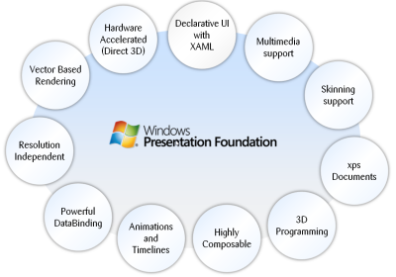

Windows Presentation Foundation (WPF) is a next-generation presentation system for building Windows client applications with visually stunning user experiences. With WPF, you can create a wide range of both standalone and browser-hosted applications.

Windows Presentation Foundation (WPF) provides developers with a unified programming model for building rich Windows smart client user experiences that incorporate UI, media, and documents. Windows Presentation Foundation (WPF) is a next-generation presentation system for building Windows client applications with visually stunning user experiences. With WPF, you can create a wide range of both standalone and browser-hosted applications. The core of WPF is a resolution-independent and vector-based rendering engine that is built to take advantage of modern graphics hardware. WPF extends the core with a comprehensive set of application-development features that include Extensible Application Markup Language (XAML), controls, data binding, layout, 2-D and 3-D graphics, animation, styles, templates, documents, media, text, and typography. WPF is included in the Microsoft .NET Framework, so you can build applications that incorporate other elements of the .NET Framework class library.

The core of WPF is a resolution-independent and vector-based rendering engine that is built to take advantage of modern graphics hardware. WPF extends the core with a comprehensive set of application-development features that include Extensible Application Markup Language (XAML), controls, data binding, layout, 2-D and 3-D graphics, animation, styles, templates, documents, media, text, and typography. WPF is included in the Microsoft .NET Framework, so you can build applications that incorporate other elements of the .NET Framework class library.

#### Programming with wpf

WPF exists as a subset of .NET Framework types that are for the most part located in the [System.Windows](http://msdn.microsoft.com/en-IN/library/system.windows.aspx) namespace. If you have previously built applications with .NET Framework using managed technologies like ASP.NET and Windows Forms, the fundamental WPF programming experience should be familiar; you instantiate classes, set properties, call methods, and handle events, all using your favorite .NET Framework programming language, such as C# or Visual Basic.

#### Markup & code-behind

WPF offers additional programming enhancements for Windows client application development. One obvious enhancement is the ability to develop an application using both *markup* and *code-behind*, an experience that ASP.NET developers should be familiar with. You generally use Extensible Application Markup Language (XAML) markup to implement the appearance of an application while using managed programming languages (code-behind) to implement its behavior.

#### security

Because XBAPs are hosted in a browser, security is important. In particular, a partial-trust security sandbox is used by XBAPs to enforce restrictions that are less than or equal to the restrictions imposed on HTML-based applications. Furthermore, each HTML feature that is safe to run from XBAPs in partial trust has been tested using a comprehensive security process.

#### controls

The user experiences that are delivered by the application model are constructed controls. In WPF, "control" is an umbrella term that applies to a category of WPF classes that are hosted in either a window or a page, have a user interface (UI), and implement some behavior.

#### Wpf controls by function

The built-in WPF controls are listed here.

* **Buttons**: [Button](http://msdn.microsoft.com/en-IN/library/system.windows.controls.button.aspx) and [RepeatButton](http://msdn.microsoft.com/en-IN/library/system.windows.controls.primitives.repeatbutton.aspx).
* **Data Display**: [DataGrid](http://msdn.microsoft.com/en-IN/library/system.windows.controls.datagrid.aspx), [ListView](http://msdn.microsoft.com/en-IN/library/system.windows.controls.listview.aspx),and [TreeView](http://msdn.microsoft.com/en-IN/library/system.windows.controls.treeview.aspx).
* **Date Display and Selection**: [Calendar](http://msdn.microsoft.com/en-IN/library/system.windows.controls.calendar.aspx) and [DatePicker](http://msdn.microsoft.com/en-IN/library/system.windows.controls.datepicker.aspx).
* **Dialog Boxes**: [OpenFileDialog](http://msdn.microsoft.com/en-IN/library/microsoft.win32.openfiledialog.aspx), [PrintDialog](http://msdn.microsoft.com/en-IN/library/system.windows.controls.printdialog.aspx), and [SaveFileDialog](http://msdn.microsoft.com/en-IN/library/microsoft.win32.savefiledialog.aspx).
* **Digital Ink**: [InkCanvas](http://msdn.microsoft.com/en-IN/library/system.windows.controls.inkcanvas.aspx) and [InkPresenter](http://msdn.microsoft.com/en-IN/library/system.windows.controls.inkpresenter.aspx).
* **Documents**: [DocumentViewer](http://msdn.microsoft.com/en-IN/library/system.windows.controls.documentviewer.aspx), [FlowDocumentPageViewer](http://msdn.microsoft.com/en-IN/library/system.windows.controls.flowdocumentpageviewer.aspx), [FlowDocumentReader](http://msdn.microsoft.com/en-IN/library/system.windows.controls.flowdocumentreader.aspx), [FlowDocumentScrollViewer](http://msdn.microsoft.com/en-IN/library/system.windows.controls.flowdocumentscrollviewer.aspx), and[StickyNoteControl](http://msdn.microsoft.com/en-IN/library/system.windows.controls.stickynotecontrol.aspx).
* **Input**: [TextBox](http://msdn.microsoft.com/en-IN/library/system.windows.controls.textbox.aspx), [RichTextBox](http://msdn.microsoft.com/en-IN/library/system.windows.controls.richtextbox.aspx), and [PasswordBox](http://msdn.microsoft.com/en-IN/library/system.windows.controls.passwordbox.aspx).
* **Layout**: [Border](http://msdn.microsoft.com/en-IN/library/system.windows.controls.border.aspx), [BulletDecorator](http://msdn.microsoft.com/en-IN/library/system.windows.controls.primitives.bulletdecorator.aspx), [Canvas](http://msdn.microsoft.com/en-IN/library/system.windows.controls.canvas.aspx), [DockPanel](http://msdn.microsoft.com/en-IN/library/system.windows.controls.dockpanel.aspx), [Expander](http://msdn.microsoft.com/en-IN/library/system.windows.controls.expander.aspx), [Grid](http://msdn.microsoft.com/en-IN/library/system.windows.controls.grid.aspx), [GridView](http://msdn.microsoft.com/en-IN/library/system.windows.controls.gridview.aspx), [GridSplitter](http://msdn.microsoft.com/en-IN/library/system.windows.controls.gridsplitter.aspx), [GroupBox](http://msdn.microsoft.com/en-IN/library/system.windows.controls.groupbox.aspx), [Panel](http://msdn.microsoft.com/en-IN/library/system.windows.controls.panel.aspx),[ResizeGrip](http://msdn.microsoft.com/en-IN/library/system.windows.controls.primitives.resizegrip.aspx), [Separator](http://msdn.microsoft.com/en-IN/library/system.windows.controls.separator.aspx), [ScrollBar](http://msdn.microsoft.com/en-IN/library/system.windows.controls.primitives.scrollbar.aspx), [ScrollViewer](http://msdn.microsoft.com/en-IN/library/system.windows.controls.scrollviewer.aspx), [StackPanel](http://msdn.microsoft.com/en-IN/library/system.windows.controls.stackpanel.aspx), [Thumb](http://msdn.microsoft.com/en-IN/library/system.windows.controls.primitives.thumb.aspx), [Viewbox](http://msdn.microsoft.com/en-IN/library/system.windows.controls.viewbox.aspx), [VirtualizingStackPanel](http://msdn.microsoft.com/en-IN/library/system.windows.controls.virtualizingstackpanel.aspx), [Window](http://msdn.microsoft.com/en-IN/library/system.windows.window.aspx), and[WrapPanel](http://msdn.microsoft.com/en-IN/library/system.windows.controls.wrappanel.aspx).
* **Media**: [Image](http://msdn.microsoft.com/en-IN/library/system.windows.controls.image.aspx), [MediaElement](http://msdn.microsoft.com/en-IN/library/system.windows.controls.mediaelement.aspx), and [SoundPlayerAction](http://msdn.microsoft.com/en-IN/library/system.windows.controls.soundplayeraction.aspx).
* **Menus**: [ContextMenu](http://msdn.microsoft.com/en-IN/library/system.windows.controls.contextmenu.aspx), [Menu](http://msdn.microsoft.com/en-IN/library/system.windows.controls.menu.aspx), and [ToolBar](http://msdn.microsoft.com/en-IN/library/system.windows.controls.toolbar.aspx).
* **Navigation**: [Frame](http://msdn.microsoft.com/en-IN/library/system.windows.controls.frame.aspx), [Hyperlink](http://msdn.microsoft.com/en-IN/library/system.windows.documents.hyperlink.aspx), [Page](http://msdn.microsoft.com/en-IN/library/system.windows.controls.page.aspx), [NavigationWindow](http://msdn.microsoft.com/en-IN/library/system.windows.navigation.navigationwindow.aspx), and [TabControl](http://msdn.microsoft.com/en-IN/library/system.windows.controls.tabcontrol.aspx).
* **Selection**: [CheckBox](http://msdn.microsoft.com/en-IN/library/system.windows.controls.checkbox.aspx), [ComboBox](http://msdn.microsoft.com/en-IN/library/system.windows.controls.combobox.aspx), [ListBox](http://msdn.microsoft.com/en-IN/library/system.windows.controls.listbox.aspx), [RadioButton](http://msdn.microsoft.com/en-IN/library/system.windows.controls.radiobutton.aspx), and [Slider](http://msdn.microsoft.com/en-IN/library/system.windows.controls.slider.aspx).
* **User Information**: [AccessText](http://msdn.microsoft.com/en-IN/library/system.windows.controls.accesstext.aspx), [Label](http://msdn.microsoft.com/en-IN/library/system.windows.controls.label.aspx), [Popup](http://msdn.microsoft.com/en-IN/library/system.windows.controls.primitives.popup.aspx), [ProgressBar](http://msdn.microsoft.com/en-IN/library/system.windows.controls.progressbar.aspx), [StatusBar](http://msdn.microsoft.com/en-IN/library/system.windows.controls.primitives.statusbar.aspx), [TextBlock](http://msdn.microsoft.com/en-IN/library/system.windows.controls.textblock.aspx), and [ToolTip](http://msdn.microsoft.com/en-IN/library/system.windows.controls.tooltip.aspx).

#### layout

When you create a UI, you arrange your controls by location and size to form a layout. A key requirement of any layout is to adapt to changes in window size and display settings. Rather than forcing you to write the code to adapt a layout in these circumstances, WPF provides a first-class, extensible layout system for you.

The cornerstone of the layout system is relative positioning, which increases the ability to adapt to changing window and display conditions. In addition, the layout system manages the negotiation between controls to determine the layout. The negotiation is a two-step process: first, a control tells its parent what location and size it requires; second, the parent tells the control what space it can have.

The layout system is exposed to child controls through base WPF classes. For common layouts such as grids, stacking, and docking, WPF includes several layout controls:

* [Canvas](http://msdn.microsoft.com/en-IN/library/system.windows.controls.canvas.aspx) : Child controls provide their own layout.
* [DockPanel](http://msdn.microsoft.com/en-IN/library/system.windows.controls.dockpanel.aspx) : Child controls are aligned to the edges of the panel.
* [Grid](http://msdn.microsoft.com/en-IN/library/system.windows.controls.grid.aspx) : Child controls are positioned by rows and columns.
* [StackPanel](http://msdn.microsoft.com/en-IN/library/system.windows.controls.stackpanel.aspx) : Child controls are stacked either vertically or horizontally.
* [VirtualizingStackPanel](http://msdn.microsoft.com/en-IN/library/system.windows.controls.virtualizingstackpanel.aspx) : Child controls are virtualized and arranged on a single line that is either horizontally or vertically oriented.
* [WrapPanel](http://msdn.microsoft.com/en-IN/library/system.windows.controls.wrappanel.aspx) : Child controls are positioned in left-to-right order and wrapped to the next line when there are more controls on the current line than space allows.

#### graphics

WPF introduces an extensive, scalable, and flexible set of graphics features that have the following benefits:

* **Resolution-independent and device-independent graphics**. The basic unit of measurement in the WPF graphics system is the device independent pixel, which is 1/96th of an inch, regardless of actual screen resolution, and provides the foundation for resolution-independent and device-independent rendering. Each device-independent pixel automatically scales to match the dots-per-inch (dpi) setting of the system it renders on.
* **Improved precision**. The WPF coordinate system is measured with double-precision floating-point numbers rather than single-precision. Transformations and opacity values are also expressed as double-precision. WPF also supports a wide color gamut (scRGB) and provides integrated support for managing inputs from different color spaces.
* **Advanced graphics and animation support**. WPF simplifies graphics programming by managing animation scenes for you; there is no need to worry about scene processing, rendering loops, and bilinear interpolation. Additionally, WPF provides hit-testing support and full alpha-compositing support.
* **Hardware acceleration**. The WPF graphics system takes advantage of graphics hardware to minimize CPU usage.

### Extensible application Markup Language (XaML)



XAML stands for Extensible Application Markup Language. Its a simple language based on XML to create and initialize .NET objects with hierarchical relations. Although it was originally invented for WPF it can by used to create any kind of object trees.

Today XAML is used to create user interfaces in WPF, Silverlight, declare workflows in WF and for electronic paper in the XPS standard.

All classes in WPF have parameter less constructors and make excessive usage of properties. That is done to make it perfectly fit for XML languages like XAML.

All you can do in XAML can also be done in code. XAML ist just another way to create and initialize objects. You can use WPF without using XAML. It's up to you if you want to declare it in XAML or write it in code. Declare your UI in XAML has some advantages:

* XAML code is short and clear to read
* Separation of designer code and logic
* Graphical design tools like Expression Blend require XAML as source.
* The separation of XAML and UI logic allows it to clearly separate the roles of designer and developer.

## Programming Framework

### .NET 4.5



The .NET Framework is a development platform for building apps for Windows, Windows Phone, Windows Server, and Windows Azure. It consists of the common language runtime (CLR) and the .NET Framework class library, which includes classes, interfaces, and value types that support an extensive range of technologies. The .NET Framework provides a managed execution environment, simplified development and deployment, and integration with a variety of programming languages, including Visual Basic and Visual C#.

#### .net framework class libraries

The .NET Framework class library is a library of classes, interfaces, and value types that provide access to system functionality. It is the foundation on which .NET Framework applications, components, and controls are built. The namespaces and namespace categories in the class library are listed in the following table and documented in detail in this reference. The namespaces and categories are listed by usage, with the most frequently used namespaces appearing first.

|  |  |
| --- | --- |
| **Namespace** | **Description** |
| [System](http://msdn.microsoft.com/en-us/library/system.aspx) | The [System](http://msdn.microsoft.com/en-us/library/system.aspx) namespace contains fundamental classes and base classes that define commonly-used value and reference data types, events and event handlers, interfaces, attributes, and processing exceptions. |
| [System.Activities](http://msdn.microsoft.com/en-us/library/gg145022.aspx) | The System.Activities namespaces contain all the classes necessary to create and work with activities in Window Workflow Foundation. |
| [System.AddIn](http://msdn.microsoft.com/en-us/library/gg145020.aspx) | The System.AddIn namespaces contain types used to identify, register, activate, and control add-ins, and to allow add-ins to communicate with a host application. |
| [System.CodeDom](http://msdn.microsoft.com/en-us/library/gg145034.aspx) | The System.CodeDom namespaces contain classes that represent the elements of a source code document and that support the generation and compilation of source code in supported programming languages. |
| [System.Collections](http://msdn.microsoft.com/en-us/library/gg145035.aspx) | The System.Collections namespaces contain types that define various standard, specialized, and generic collection objects. |
| [System.ComponentModel](http://msdn.microsoft.com/en-us/library/gg145042.aspx) | The System.ComponentModel namespaces contain types that implement the run-time and design-time behavior of components and controls. Child namespaces support the Managed Extensibility Framework (MEF), provide attribute classes that define metadata for ASP.NET Dynamic Data controls, and contain types that let you define the design-time behavior of components and their user interfaces. |
| [System.Configuration](http://msdn.microsoft.com/en-us/library/gg145027.aspx) | The System.Configuration namespaces contain types for handling configuration data, such as data in machine or application configuration files. Child namespaces contain types that are used to configure an assembly, to write custom installers for components, and to support a pluggable model for adding functionality to, or removing functionality from, both client and server applications. |
| [System.Data](http://msdn.microsoft.com/en-us/library/gg145028.aspx) | The System.Data namespaces contain classes for accessing and managing data from diverse sources. The top-level namespace and a number of the child namespaces together form the ADO.NET architecture and ADO.NET data providers. For example, providers are available for SQL Server, Oracle, ODBC, and OleDB. Other child namespaces contain classes used by the ADO.NET Entity Data Model (EDM) and by WCF Data Services. |
| [System.Deployment](http://msdn.microsoft.com/en-us/library/gg145029.aspx) | The System.Deployment namespaces contain types that support deployment of ClickOnce applications. |
| [System.Device.Location](http://msdn.microsoft.com/en-us/library/system.device.location.aspx) | The [System.Device.Location](http://msdn.microsoft.com/en-us/library/system.device.location.aspx) namespace allows application developers to easily access the computer's location by using a single API. Location information may come from multiple providers, such as GPS, Wi-Fi triangulation, and cell phone tower triangulation. The [System.Device.Location](http://msdn.microsoft.com/en-us/library/system.device.location.aspx) classes provide a single API to encapsulate the multiple location providers on a computer and support seamless prioritization and transitioning between them. As a result, application developers who use this API do not need to tailor applications to specific hardware configurations. |
| [System.Diagnostics](http://msdn.microsoft.com/en-us/library/gg145030.aspx) | The System.Diagnostics namespaces contain types that enable you to interact with system processes, event logs, and performance counters. Child namespaces contain types to interact with code analysis tools, to support contracts, to extend design-time support for application monitoring and instrumentation, to log event data using the Event Tracing for Windows (ETW) tracing subsystem, to read to and write from event logs and collect performance data, and to read and write debug symbol information. |
| [System.DirectoryServices](http://msdn.microsoft.com/en-us/library/gg145037.aspx) | The System.DirectoryServices namespaces contain types that provide access to Active Directory from managed code. |
| [System.Drawing](http://msdn.microsoft.com/en-us/library/gg145023.aspx) | The System.Drawing parent namespace contains types that support basic GDI+ graphics functionality. Child namespaces support advanced two-dimensional and vector graphics functionality, advanced imaging functionality, and print-related and typographical services. A child namespace also contains types that extend design-time user-interface logic and drawing. |
| [System.Dynamic](http://msdn.microsoft.com/en-us/library/system.dynamic.aspx) | The [System.Dynamic](http://msdn.microsoft.com/en-us/library/system.dynamic.aspx) namespace provides classes and interfaces that support Dynamic Language Runtime. |
| [System.EnterpriseServices](http://msdn.microsoft.com/en-us/library/gg145047.aspx) | The System.EnterpriseServices namespaces contain types that define the COM+ services architecture, which provides an infrastructure for enterprise applications. A child namespace supports Compensating Resource Manager (CRM), a COM+ service that enables non-transactional objects to be included in Microsoft Distributed Transaction Coordinator (DTC) transactions. Child namespaces are described briefly in the following table and documented in detail in this reference. |
| [System.Globalization](http://msdn.microsoft.com/en-us/library/system.globalization.aspx) | The [System.Globalization](http://msdn.microsoft.com/en-us/library/system.globalization.aspx) namespace contains classes that define culture-related information, including language, country/region, calendars in use, format patterns for dates, currency, and numbers, and sort order for strings. These classes are useful for writing globalized (internationalized) applications. Classes such as [StringInfo](http://msdn.microsoft.com/en-us/library/system.globalization.stringinfo.aspx) and[TextInfo](http://msdn.microsoft.com/en-us/library/system.globalization.textinfo.aspx) provide advanced globalization functionalities, including surrogate support and text element processing. |
| [System.IdentityModel](http://msdn.microsoft.com/en-us/library/gg145031.aspx) | The System.IdentityModel namespaces contain types that are used to provide authentication and authorization for .NET applications. |
| [System.IO](http://msdn.microsoft.com/en-us/library/gg145019.aspx) | The System.IO namespaces contain types that support input and output, including the ability to read and write data to streams either synchronously or asynchronously, to compress data in streams, to create and use isolated stores, to map files to an application's logical address space, to store multiple data objects in a single container, to communicate using anonymous or named pipes, to implement custom logging, and to handle the flow of data to and from serial ports. |
| [System.Linq](http://msdn.microsoft.com/en-us/library/gg145016.aspx) | The System.Linq namespaces contain types that support queries that use Language-Integrated Query (LINQ). This includes types that represent queries as objects in expression trees. |
| [System.Management](http://msdn.microsoft.com/en-us/library/gg145024.aspx) | The System.Management namespaces contain types that provide access to management information and management events about the system, devices, and applications instrumented to the Windows Management Instrumentation (WMI) infrastructure. These namespaces also contain types necessary for instrumenting applications so that they expose their management information and events through WMI to potential customers. |
| [System.Media](http://msdn.microsoft.com/en-us/library/system.media.aspx) | The [System.Media](http://msdn.microsoft.com/en-us/library/system.media.aspx) namespace contains classes for playing sound files and accessing sounds provided by the system. |
| [System.Messaging](http://msdn.microsoft.com/en-us/library/gg145046.aspx) | The System.Messaging namespaces contain types that enable you to connect to, monitor, and administer message queues on the network and to send, receive, or peek messages. A child namespace contains classes that can be used to extend design-time support for messaging classes. |
| [System.Net](http://msdn.microsoft.com/en-us/library/gg145039.aspx) | The System.Net namespaces contain classes that provide a simple programming interface for a number of network protocols, programmatically access and update configuration settings for the System.Net namespaces, define cache policies for web resources, compose and send e-mail, represent Multipurpose Internet Mail Exchange (MIME) headers, access network traffic data and network address information, and access peer-to-peer networking functionality. Additional child namespaces provide a managed implementation of the Windows Sockets (Winsock) interface and provide access to network streams for secure communications between hosts. |
| [System.Numerics](http://msdn.microsoft.com/en-us/library/system.numerics.aspx) | The [System.Numerics](http://msdn.microsoft.com/en-us/library/system.numerics.aspx) namespace contains numeric types that complement the numeric primitives, such as [Byte](http://msdn.microsoft.com/en-us/library/system.byte.aspx), [Double](http://msdn.microsoft.com/en-us/library/system.double.aspx), and [Int32](http://msdn.microsoft.com/en-us/library/system.int32.aspx), that are defined by the .NET Framework. |
| [System.Printing](http://msdn.microsoft.com/en-us/library/gg145044.aspx) | The System.Printing namespaces contain types that support printing, that provide access to the properties of print system objects and enable rapid copying of their property settings to another object of the same type, and that support the interconversion of managed System.PrintTicket objects and unmanaged GDI DEVMODE structures. |
| [System.Reflection](http://msdn.microsoft.com/en-us/library/gg145033.aspx) | The System.Reflection namespaces contain types that provide a managed view of loaded types, methods, and fields, and that can dynamically create and invoke types. A child namespace contains types that enable a compiler or other tool to emit metadata and Microsoft intermediate language (MSIL). |
| [System.Resources](http://msdn.microsoft.com/en-us/library/gg145043.aspx) | The System.Resources namespaces contain types that enable developers to create, store, and manage an application's culture-specific resources. |
| [System.Runtime](http://msdn.microsoft.com/en-us/library/gg145017.aspx) | The System.Runtime namespaces contain types that support an application's interaction with the common language runtime, and types that enable features such as application data caching, advanced exception handling, application activation within application domains, COM interop, distributed applications, serialization and deserialization, and versioning. Additional namespaces enable compiler writers to specify attributes that affect the run-time behavior of the common language runtime, define a contract for reliability between a set of code and other code that takes a dependency on it, and implement a persistence provider for Windows Communication Foundation (WCF). |
| [System.Security](http://msdn.microsoft.com/en-us/library/gg145025.aspx) | The System.Security namespaces contain classes that represent the .NET Framework security system and permissions. Child namespaces provide types that control access to and audit securable objects, allow authentication, provide crytographic services, control access to operations and resources based on policy, and support rights management of application-created content. |
| [System.ServiceModel](http://msdn.microsoft.com/en-us/library/gg145010.aspx) | The System.ServiceModel namespaces contain the types necessary to build Windows Communication Foundation (WCF) service and client applications. |
| [System.ServiceProcess](http://msdn.microsoft.com/en-us/library/gg145038.aspx) | The System.ServiceProcess namespaces contain types that enable you to implement, install, and control Windows service applications and extend design-time support for Windows service applications. |
| [System.Speech](http://msdn.microsoft.com/en-us/library/gg145021.aspx) | The System.Speech namespaces contain types that support speech recognition. |
| [System.Text](http://msdn.microsoft.com/en-us/library/gg145012.aspx) | The System.Text namespaces contain types for character encoding and string manipulation. A child namespace enables you to process text using regular expressions. |
| [System.Threading](http://msdn.microsoft.com/en-us/library/gg145014.aspx) | The System.Threading namespaces contain types that enable multithreaded programming. A child namespace provides types that simplify the work of writing concurrent and asynchronous code. |
| [System.Timers](http://msdn.microsoft.com/en-us/library/system.timers.aspx) | The [System.Timers](http://msdn.microsoft.com/en-us/library/system.timers.aspx) namespace provides the [Timer](http://msdn.microsoft.com/en-us/library/system.timers.timer.aspx) component, which allows you to raise an event on a specified interval. |
| [System.Transactions](http://msdn.microsoft.com/en-us/library/gg145032.aspx) | The System.Transactions namespaces contain types that support transactions with multiple, distributed participants, multiple phase notifications, and durable enlistments. A child namespace contains types that describe the configuration options used by the System.Transactions types. |
| [System.Web](http://msdn.microsoft.com/en-us/library/gg145018.aspx) | The System.Web namespaces contain types that enable browser/server communication. Child namespaces include types that support ASP.NET forms authentication, application services, data caching on the server, ASP.NET application configuration, dynamic data, HTTP handlers, JSON serialization, incorporating AJAX functionality into ASP.NET, ASP.NET security, and web services. |
| [System.Windows](http://msdn.microsoft.com/en-us/library/gg145013.aspx) | The System.Windows namespaces contain types used in Windows Presentation Foundation (WPF) applications, including animation clients, user interface controls, data binding, and type conversion. System.Windows.Forms and its child namespaces are used for developing Windows Forms applications. |
| [System.Workflow](http://msdn.microsoft.com/en-us/library/gg145026.aspx) | The System.Workflow namespaces contain types used to develop applications that use Windows Workflow Foundation. These types provide design time and run-time support for rules and activities, to configure, control, host, and debug the workflow runtime engine. |
| [System.Xaml](http://msdn.microsoft.com/en-us/library/gg145048.aspx) | The System.Xaml namespaces contain types that support parsing and processing the Extensible Application Markup Language (XAML). |
| [System.Xml](http://msdn.microsoft.com/en-us/library/gg145036.aspx) | The System.Xml namespaces contain types for processing XML. Child namespaces support serialization of XML documents or streams, XSD schemas, XQuery 1.0 and XPath 2.0, and LINQ to XML, which is an in-memory XML programming interface that enables easy modification of XML documents. |
| [Accessibility](http://msdn.microsoft.com/en-us/library/accessibility.aspx) | The [Accessibility](http://msdn.microsoft.com/en-us/library/accessibility.aspx) and all of its exposed members are part of a managed wrapper for the Component Object Model (COM) accessibility interface. |
| [Microsoft.Activities](http://msdn.microsoft.com/en-us/library/hh135392.aspx) | The Microsoft.Activities namespaces contain types that support MSBuild and debugger extensions for Windows Workflow Foundation applications. |
| [Microsoft.Aspnet.Snapin](http://msdn.microsoft.com/en-us/library/microsoft.aspnet.snapin.aspx) | The [Microsoft.Aspnet.Snapin](http://msdn.microsoft.com/en-us/library/microsoft.aspnet.snapin.aspx) namespace defines the types necessary for the ASP.NET management console application to interact with Microsoft Management Console (MMC). For more information, see "MMC Programmer's Guide" in the [MSDN Library](http://go.microsoft.com/fwlink/?linkid=37118). |
| [Microsoft.Build](http://msdn.microsoft.com/en-us/library/gg145008.aspx) | The Microsoft.Build namespaces contain types that provide programmatic access to, and control of, the MSBuild engine. |
| [Microsoft.CSharp](http://msdn.microsoft.com/en-us/library/gg145015.aspx) | The Microsoft.CSharp namespaces contain types that support compilation and code generation of source code written in the C# language, and types that support interoperation betwen the dynamic language runtime (DLR) and C#. |
| [Microsoft.Data.Entity.Build.Tasks](http://msdn.microsoft.com/en-us/library/microsoft.data.entity.build.tasks.aspx) | The [Microsoft.Data.Entity.Build.Tasks](http://msdn.microsoft.com/en-us/library/microsoft.data.entity.build.tasks.aspx) namespace contains two MSBuild tasks that are used by the ADO.NET Entity Data Model Designer (Entity Designer). |
| [Microsoft.JScript](http://msdn.microsoft.com/en-us/library/gg145041.aspx) | The Microsoft.JScript namespaces contain classes that support compilation and code generation using the JScript language. |
| [Microsoft.SqlServer.Server](http://msdn.microsoft.com/en-us/library/microsoft.sqlserver.server.aspx) | The [Microsoft.SqlServer.Server](http://msdn.microsoft.com/en-us/library/microsoft.sqlserver.server.aspx) namespace contains classes, interfaces, and enumerations that are specific to the integration of the Microsoft .NET Framework common language runtime (CLR) into Microsoft SQL Server, and the SQL Server database engine process execution environment. |
| [Microsoft.VisualBasic](http://msdn.microsoft.com/en-us/library/gg145009.aspx) | The Microsoft.VisualBasic namespaces contain classes that support compilation and code generation using the Visual Basic language. Child namespaces contain types that provide services to the Visual Basic compiler and types that include support for the Visual Basic application model, the My namespace, lambda expressions, and code conversion. |
| [Microsoft.VisualC](http://msdn.microsoft.com/en-us/library/gg145040.aspx) | The Microsoft.VisualC namespaces contain types that support the Visual C++ compiler and types that implement the STL/CLR Library and the generic interface to the STL/CLR Library. |
| [Microsoft.Win32](http://msdn.microsoft.com/en-us/library/gg145011.aspx) | The Microsoft.Win32 namespaces provide types that handle events raised by the operating system, that manipulate the system registry, and that represent file and operating system handles. |
| [Microsoft.Windows](http://msdn.microsoft.com/en-us/library/hh135393.aspx) | The Microsoft.Windows namespaces contain types that support themes and preview in Windows Presentation Framework (WPF) applications. |
| [UIAutomationClientsideProviders](http://msdn.microsoft.com/en-us/library/uiautomationclientsideproviders.aspx) | Contains a single type that maps client automation providers. |
| [XamlGeneratedNamespace](http://msdn.microsoft.com/en-us/library/xamlgeneratednamespace.aspx) | Contains compiler-generated types that are not intended to be used directly from your code. |

## Database/backend:

### MySQL

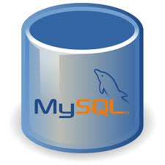

MySQL is the world's most popular open source database software, with over 100 million copies of its software downloaded or distributed throughout its history.

The MySQL Community Edition includes:

* Pluggable Storage Engine Architecture
* Multiple Storage Engines: InnoDB , MyISAM, NDB (MySQL Cluster),Memory ,Merge , Archive, CSV
* MySQL Replication to improve application performance and scalability
* MySQL Partitioning to improve performance and management of large database applications
* Stored Procedures to improve developer productivity

#### Detailed features of mysql

The following list shows the most important properties of MySQL. This section is directed to the reader who already has some knowledge of relational databases. We will use some terminology from the relational database world without defining our terms exactly. On the other hand, the explanations should make it possible for database novices to understand to some extent what we are talking about.

**Relational Database System:** Like almost all other database systems on the market, MySQL is a relational database system.

**Client/Server Architecture:** MySQL is a client/server system. There is a database server (MySQL) and arbitrarily many clients (application programs), which communicate with the server; that is, they query data, save changes, etc. The clients can run on the same computer as the server or on another computer (communication via a local network or the Internet).

|  |  |
| --- | --- |
|  | |
|  |  |
|  | |

Almost all of the familiar large database systems (Oracle, Microsoft SQL Server, etc.) are client/server systems. These are in contrast to the file-server systems, which include Microsoft Access, dBase and FoxPro. The decisive drawback to file-server systems is that when run over a network, they become extremely inefficient as the number of users grows.

**SQL compatibility:** MySQL supports as its database language -- as its name suggests – SQL (Structured Query Language). SQL is a standardized language for querying and updating data and for the administration of a database. There are several SQL dialects (about as many as there are database systems). MySQL adheres to the current SQL standard (at the moment SQL:2003), although with significant restrictions and a large number of extensions.

Through the configuration setting sql-mode you can make the MySQL server behave for the most part compatibly with various database systems. Among these are IBM DB/2 and Oracle. (The setting sql-mode changes some of the syntax conventions, and performs no miracles.

**SubSELECTs:** Since version 4.1, MySQL is capable of processing a query in the form SELECT \* FROM table1 WHERE x IN (SELECT y FROM table2) (There are also numerous syntax variants for subSELECTs.)

**Views:** Put simply, views relate to an SQL query that is viewed as a distinct database object and makes possible a particular view of the database. MySQL has supported views since version 5.0.

**Stored procedures:** Here we are dealing with SQL code that is stored in the database system.

Stored procedures (SPs for short) are generally used to simplify certain steps, such as inserting or deleting a data record. For client programmers this has the advantage that they do not have to process the tables directly, but can rely on SPs. Like views, SPs help in the administration of large database projects. SPs can also increase efficiency. MySQL has supported SPs since version 5.0.

**Triggers:** Triggers are SQL commands that are automatically executed by the server in certain database operations (INSERT, UPDATE, and DELETE). MySQL has supported triggers in a limited form from version 5.0, and additional functionality is promised for version 5.1.

**Unicode:** MySQL has supported all conceivable character sets since version 4.1, including Latin-1, Latin-2, and Unicode (either in the variant UTF8 or UCS2).

**User interface:** There are a number of convenient user interfaces for administering a MySQL server.

**Full-text search:** Full-text search simplifies and accelerates the search for words that are located within a text field. If you employ MySQL for storing text (such as in an Internet discussion group), you can use full-text search to implement simply an efficient search function.

**Replication:** Replication allows the contents of a database to be copied (replicated) onto a number of computers. In practice, this is done for two reasons: to increase protection against system failure (so that if one computer goes down, another can be put into service) and to improve the speed of database queries.

**Transactions:** In the context of a database system, a transaction means the execution of several database operations as a block. The database system ensures that either all of the operations are correctly executed or none of them. This holds even if in the middle of a transaction there is a power failure, the computer crashes, or some other disaster occurs. Thus, for example, it cannot occur that a sum of money is withdrawn from account A but fails to be deposited in account B due to some type of system error.

Transactions also give programmers the possibility of interrupting a series of already executed commands (a sort of revocation). In many situations this leads to a considerable simplification of the programming process. In spite of popular opinion, MySQL has supported transactions for a long time. One should note here that MySQL can store tables in a variety of formats. The default table format is called MyISAM, and this format does not support transactions. But there are a number of additional formats that do support transactions. The most popular of these is InnoDB, which will be described extensively in this book.

**Foreign key constraints:** These are rules that ensure that there are no cross references in linked tables that lead to nowhere. MySQL supports foreign key constraints for InnoDB tables.

**GIS functions:** Since version 4.1, MySQL has supported the storing and processing of two-dimensional geographical data. Thus MySQL is well suited for GIS (geographic information systems) applications.

**Programming languages:** There are quite a number of APIs (application programming interfaces) and libraries for the development of MySQL applications. For client programming you can use, among others, the languages C, C++, Java, Perl, PHP, Python, and Tcl.

**ODBC:** MySQL supports the ODBC interface [Connector/ODBC](http://searchenterpriselinux.techtarget.com/definition/MySQL-Connector-ODBC). This allows MySQL to be addressed by all the usual programming languages that run under Microsoft Windows (Delphi, Visual Basic, etc.). The ODBC interface can also be implemented under Unix, though that is seldom necessary.

Windows programmers who have migrated to Microsoft's new .NET platform can, if they wish, use the ODBC provider or the .NET interface Connector/NET.

**Platform independence:** It is not only client applications that run under a variety of operating systems; MySQL itself (that is, the server) can be executed under a number of operating systems. The most important are Apple Macintosh OS X, Linux, Microsoft Windows, and the countless Unix variants, such as AIX, BSDI, FreeBSD, HP-UX, OpenBSD, Net BSD, SGI Iris, and Sun Solaris.

**Speed:** MySQL is considered a very fast database program. This speed has been backed up by a large number of benchmark.

## ide for Database

### MySQL workbench

MySQL Workbench is a visual database design tool that integrates SQL development,administration, database design, creation and maintenance into a single integrated development environment for the MySQL database system. It is the successor to DBDesigner 4 from fabFORCE.net, and replaces the previous package of software,MySQL GUI Tools Bundle.

## Programming Language

### C# - c sharp

C# is a type-safe, object-oriented language that is simple yet powerful, allowing programmers to build a breadth of applications. C# is a [multi-paradigm programming language](http://en.wikipedia.org/wiki/Multi-paradigm_programming_language) encompassing [imperative](http://en.wikipedia.org/wiki/Imperative_programming), [declarative](http://en.wikipedia.org/wiki/Declarative_programming), [functional](http://en.wikipedia.org/wiki/Functional_programming), [generic](http://en.wikipedia.org/wiki/Generic_programming), [object-oriented](http://en.wikipedia.org/wiki/Object-oriented_programming)([class-based](http://en.wikipedia.org/wiki/Class_(computer_science))), and [component-oriented](http://en.wikipedia.org/wiki/Component-based_software_engineering) programming disciplines. It was developed by [Microsoft](http://en.wikipedia.org/wiki/Microsoft) within the [.NET](http://en.wikipedia.org/wiki/.NET_Framework) initiative and later approved as a standard by [Ecma](http://en.wikipedia.org/wiki/Ecma_International) (ECMA-334) and [ISO](http://en.wikipedia.org/wiki/International_Organization_for_Standardization) (ISO/IEC 23270). C# is one of the programming languages designed for the [Common Language Infrastructure](http://en.wikipedia.org/wiki/Common_Language_Infrastructure).

C# is intended to be a simple, modern, general-purpose, object-oriented programming language.

## Other technologies

### Dia for Diagram Drawing & Modeling

Dia is free and open source general-purpose diagramming software, developed as part of the GNOME project's office suite and was originally created by Alexander Larsson. Dia uses a controlled single document interface (CSDI) similar to GIMP and Sodipodi.

Dia has a modular design with several shape packages available for different needs: flowchart, network diagrams, circuit diagrams, and more. It does not restrict symbols and connectors from various categories from being placed together.

Dia is a gtk+ based diagram creation program released under the GPL license.

Dia is inspired by the commercial Windows program 'Visio', though more geared towards informal diagrams for casual use. It can be used to draw many different kinds of diagrams. It currently has special objects to help draw entity relationship diagrams, UML diagrams, flowcharts, network diagrams, and many other diagrams. It is also possible to add support for new shapes by writing simple XML files, using a subset of SVG to draw the shape.

It can load and save diagrams to a custom XML format (gzipped by default, to save space), can export diagrams to a number of formats, including EPS, SVG, XFIG, WMF and PNG, and can print diagrams (including ones that span multiple pages).

### Google Spreadsheet Interface:

*With Google Spreadsheets, we can easily create, share, and edit spreadsheets online. Here are a few specific things we can do:*

* *Import and export these file types: .xls, .csv, .txt and .ods. We can also export data to a PDF or an HTML file.*
* *Format cells and edit formulas so we can calculate results and make data look the way we want it.*
* *Chat in real time with others who are editing our spreadsheet.*
* *Embed a spreadsheet, or a section of a spreadsheet, in our blog or website.*

### Windows Mobile 6 Professional SDK

Windows Mobile is a mobile operating system developed by Microsoft that was used in smartphones and mobile devices. This features a suite of basic applications developed with the Microsoft Windows API. It is designed to be somewhat similar to desktop versions of Windows, feature-wise and aesthetically. Additionally, third-party software development is available for Windows Mobile, and software applications can be purchased via the Windows Marketplace for Mobile. Windows Mobile 6.1 was announced April 1, 2008. It is a minor upgrade to the existing Windows Mobile 6 platform which brings with it various performance enhancements, a redesigned Home screen featuring horizontal tiles that expand on clicking to display more information, although this new home screen is featured only on Windows Mobile Standard edition. This feature was inexplicably left out of the Professional edition. Several other changes such as threaded SMS, full page zooming in Internet Explorer and 'Domain Enroll' have also been added, along with a "mobile" version of the Microsoft OneNote program and an interactive "Getting Started" wizard. Windows Mobile 6.1 also featured improved bandwidth efficiency in its push-email protocol "Activesync" of "up to 40%", this reduced data usage was the cause of considerably improved battery life in many devices.

# GLOSSARY